**October Newsletter 2023**

Dear Parents and Guardians,

Well done all our pupils who have worked so hard over the past two months!! Well done to our Pre-school and Junior Infant Pupils who have settled in so well to the routines of school. Well done also to our Senior Infants and First classes who are working very hard and are embracing the new challenges of Senior Infants and First Class.

A special thanks to all our staff for their hard work over the past term and especially for all the work in getting the new section of our school ready to re-open. It was a very exciting first term with our First Classes and some of our Senior Infants moving into our long awaited new building! Our state of the art Special Education Suite opened also with amazing facilities for the children in room 1 and room 29. We are hopeful that the rest of the school will be moving into the next phase early in the new year.

Thanks to our parents for supporting the work of the school and in supporting your children with their learning. Thanks also for your co-operation with morning drop off, collection at home time etc. Parental support is always much appreciated and is vital for the smooth and safe running of the school.

We have had a busy first term with School Assemblies, Maths week, Planting Spring bulbs and lots of Autumn and Halloween Activities. Don’t forget to follow us on Twitter and Instagram to see updates from our school.

I hope everyone has a fun filled safe Halloween and I wish all a well- deserved midterm break.

Best wishes.

Anne-Marie O’Connor



**Parents Association**

The PA are organising a Clothes Collection on, November 21st and 22nd at the school. They will be in touch regarding Drop Off points and collection times. Over Halloween is a great time to re-organise the wardrobe and also help the PA!!

The Parents Association will also be organising the annual Christmas card project. This offers the children the opportunity to create personalised Christmas Cards while also raising money for the school.

Next meeting: Tuesday 14th Nov @ 8pm, all are welcome.



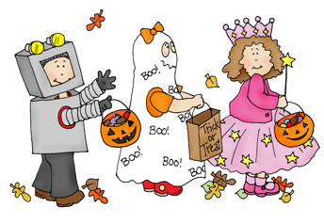

**Instagram**

For those parents who have given permission for their child’s image to possibly feature on the school Instagram page, you can request to follow: social@stconlethinfantschool.

**Maths Week 2023**

Maths Week took place in school from Monday 16th October to Friday 20th October. The children engaged in lots of different Maths activities in their classes. There were lots of counting forwards and backwards to be heard around the school. The children had the opportunity to play lots of different board games including Ludo, snakes and ladders, draughts, connect 4 to name just a few. Our Junior and Senior Infant children played Happy Faces and the Snail Trail game from our Ready Set Go games.

Classes also had the opportunity to use maths in art, music and PE lessons. We also sent parents information from the NCCA with some useful tips on how they can help their child at home with Maths. It was very exciting to welcome the 6th class students from St. Conleth’s and Marys to play board games with our First Classes. A special thank you to all the 6th class students and their teachers for coming to visit us.

On Friday we all performed our favourite number songs and poems for our Maths Week assembly and we had the opportunity to wear something with shapes, number or pattern coming to school. A fun week for all!

**Trips to the Riverbank**

We are fortunate to have the Riverbank so closely situated to us. Our First classes and Senior Infants are very excited to attend, the Polar Bears and Penguins and 100 little hills on the 1st and 6th of December. We are sure that these will be fun filled shows for us all to enjoy.





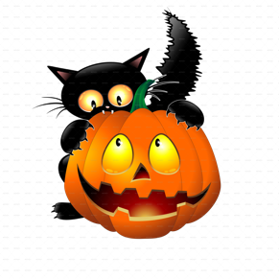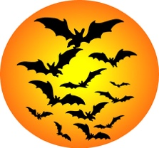

**Planting and Science Week**

The children were very busy during the month of October planting bulbs. Children in Junior Infants, Senior Infants and First Class planted a mixture of tulips and daffodils. We look forward to enjoying an abundance of colour in the Spring.

We will celebrate Science Week from the 13th of November until the 17th of November. The children will be working as scientists and will have the opportunity to explore a variety of experiments.

**Junior Infants**

Junior Infants have settled in so well to their first term in big school! The boys and girls have been very busy this term learning lots of new things and making lots of new friends. We have been learning new songs, nursery rhymes, stories and even using a lot of new words as Gaeilge!

We have been working so hard learning our new sounds and we have really enjoyed team teaching this term. At the start of the year, we made the most of the lovely weather with sand play outside. In recent weeks, some classes have even been on nature walks looking for signs of Autumn. We have really been enjoying Aistear and playtime in the Seomra Draíochta.

The past couple of months our theme has been based around 'School'. Last week, we got a chance to show how green our fingers are when we planted Spring bulbs in each class group. We are so excited to see our daffodils and tulips bloom in the Springtime. We also celebrated maths week this term and we got the chance to see how maths is all around us, from colours and shapes to numbers and patterns. One of our highlights was definitely our maths dress up day on Friday! Junior Infants have had a super term, and we can't wait for next term!



**Senior Infants**

Senior Infants have settled into our new school and their classrooms very well. We have had a very busy term! So far, the children have enjoyed taking part in maths week, where they played lots of maths games! They took a nature walk to the local park and around the school after learning all about autumn. They celebrated National Tree Day and planted spring bulbs. We are looking forward to watching them grow. They are also getting ready for their witches walk in the coming week and are excited to dress up in their costumes and perform their songs.

We wish all the senior infants and their families a Happy Halloween!



**First Class**

The boys and girls in First Class have had a very busy first half term. We have been working hard settling into the new routine and fabulous new classrooms. We have had a wonderful ‘Math’s Week’, participating in various maths activities, we even had the 6th class children from Conleth’s and Mary’s in to join us for board games. Some of the First Class children had the opportunity to pair up with Junior Infants to help them with their games.

We were sad to see Ireland miss out on a chance of winning the Rugby World Cup, but we worked hard at cheering them on with ‘Ireland’s Call’. We also learned some greetings from around the world.

The children have shown themselves to be amazing artists, and I’m sure they will be taking some wonderful masterpieces home before the break.

We have spent time talking about Autumn and observing the changing seasons. Like all good gardeners, they are looking ahead to Spring. We were planting our spring bulbs, so we will have beautiful flowers to look forward to in the new year.





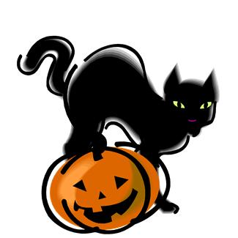

**Warm Clothes!**

When we return to school on November 6th, we can expect the weather to be colder so please ensure that the children have extra layers on coming to school. The children should wear a coat each day also.

**Halloween Walk**

The children may dress up on Friday for our fundraiser/Halloween Walk. **Please ensure** **that the children dress warmly and wear their coats**. Thank you to everyone who has supported this event. If you haven’t already done so, please send in your card by Friday. The money will be used to purchase Library books, IT equipment and update resources in our Seomra Draíochta / Playroom.

**Reminder of times for the Witch Walk**

First class and room 29: **9.50 - 10.10**

Senior Infants: **10.35 - 10.55**

Junior Infants and room 1:**11.30 - 11.50**

**School closes on Friday @ 2pm and re-opens on Monday November 6th**

**@ 9.10am for all classes.**

**Wishing everyone a happy and safe Halloween.**



