
Christmas Newsletter 2025
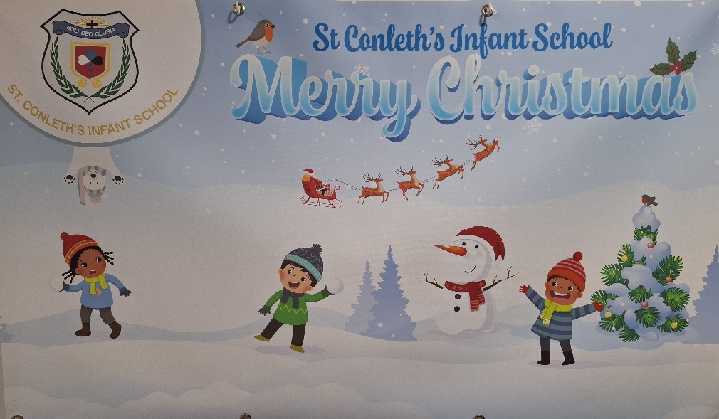
Dear Parents/ Guardians,
May I take this opportunity to wish all in our school community a very Happy Christmas and every good wish for the New Year. What an incredibly busy term it has been as you will read from this newsletter!
It has been wonderful to see the children wearing their Christmas jumpers, making wonderful Christmas Art and enjoying the fun activities that have been ongoing during the month of December. It was very special to see our First classes have their Carol Service in the Church. We were very proud of their wonderful singing and behaviour too. What fun we had at the Junior Infant Jingle and the Senior Infant Sing Along for parents and family members! We were all so impressed with their wonderful singing, actions and good behaviour too. Once again, we are reminded how lucky we are to work with children of this age especially at this time of year.
I would like to thank our pupils for their hard work over the past term, our parents for your continuing support in all that we do, our Parents Association, members of our Board of Management, the staff, teachers, SNAs, bus escorts, Bernard and Eamon our caretakers, Mary & Maria our secretary’s, our cleaning staff and all who contribute to the successful running of our school every day!

We would like to congratulate Ms. Nicola Kenna on the birth of her gorgeous baby boy Seán, Ms.O’Driscoll on the birth of her beautiful baby girl Ayla and Ms. O’Sullivan on the safe arrival of her beautiful little boy Éanna. Lots of new arrivals to join the St.Conleth’s Infant School family!
The countdown to Christmas has truly begun and perhaps Santa may bring the children some puzzles, books and hands on toys when he is packing his bag!
Wishing you all a Wonderful Christmas,
Nollaig Shona Daoibh go leir,
Anne-Marie O’Connor
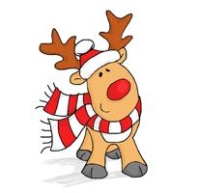




Parent /Teacher Meetings

Our parent teacher meetings were held on Thursday 27th of November. Many thanks to all the parents who visited our school and met with our teachers. It was great to meet with so many parents and welcome you all to the school.

Christmas Activities
During the month of December lots of Christmas activities were organised which both children and staff enjoyed immensely. Every classroom looked wonderful with a great selection of art activities.
Many thanks to the children from Senior Infants for performing a gorgeous prayer service to celebrate the Feast of the Immaculate Conception on Monday the 8th of December. We were delighted to welcome our chairperson of our Board of Management, Mr Pat Lonergan and Deacon Jim Stowe who give us all a Christmas blessing. Huge thanks Ms O’Connell and all the Senior Infant team for organising the prayer service and of course the school choir for providing some gorgeous carols on the day.
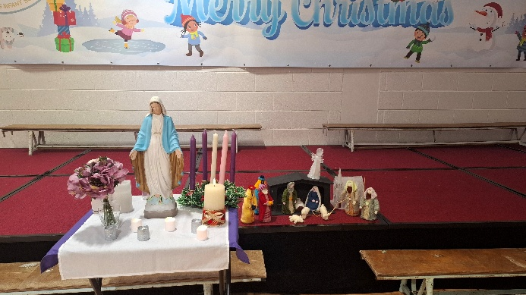

Our school choir had a very busy month of December. On Tuesday 9th of December, they performed in the convent. This was a very special occasion. On Wednesday the 10th of December they performed in the Whitewater shopping centre. Huge thanks to all involved in the school choir for their expertise and dedication.
Our Junior Infant and Senior Infant classes took part in Jingle with the Junior infants and Sing Along with the Senior Infants for their families. The children wore their Christmas jumpers and looked so festive as everyone sang several Christmas songs. Well done to everyone for making it a special time for us all.
On Wednesday 17th December our first classes performed their carol service in the church for all their families. What a special occasion this was for us all to enjoy.
On Thursday 18th of December, we enjoyed a Christmas Jumper Day.

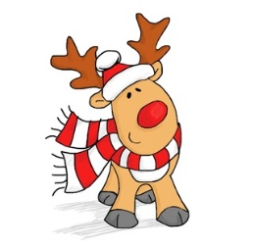
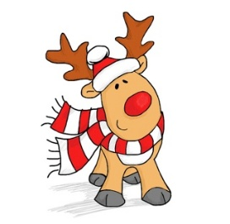
Today FM Shauna’s School Run
Guess who landed in Saint Conleth’s Infant School on Tuesday 2nd December? Only Shauna from Shauna’s School Run on Today FM!
She interviewed our brilliant children and asked them all about Christmas and the big man in red. Our school choir also sang so beautifully for Shauna.
A huge well-done to all our wonderful children—you were all superstars—and of course to the staff who made the magic happen. A special mention to Ms Fenlon for organising this fantastic opportunity for us all.

We are looking forward to hearing the boys and girls on Today FM on Thursday morning 18th of December at approx. 8.35. Be sure to tune in!

Science Week
We enjoyed a fabulous Science Week in school from 10th to 14th of November.
Each class had the opportunity to take part in an experiment throughout the week.
Our Junior Infants enjoyed the Dancing Raisins experiment, our Senior Infants explored Materials and Change and our First Classes took part in Awe and Wonder.
Our Junior Infants classes were super excited as they got to visit the Holy Family Secondary School and see a real science lab in action!
Huge thanks to all the staff and students in the Holy family for having us. We loved having the chance to wear the white lab coats and the goggles!
Our Senior Infants and First Classes enjoyed a visit from the Junior Einsteins, which we all thoroughly enjoyed.
Many thanks to Ms Mc Paul for a super week.
There are lots of future scientists among us here in St. Conleths Infant school!
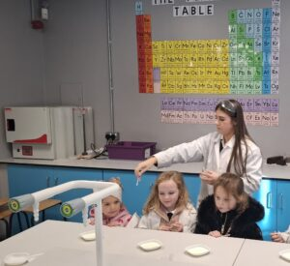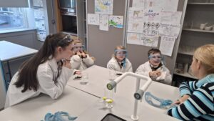

Riverbank Trips
We are fortunate to have the Riverbank so closely situated to us. In December, Our First classes had a fabulous time at “The Whistle Blast’s Christmas Carol” The children thoroughly enjoyed the show with lots of wonderful Christmas Carols for the children to enjoy. Many thanks to the Riverbank Arts Centre for having us.
A Visit from fireman Alex
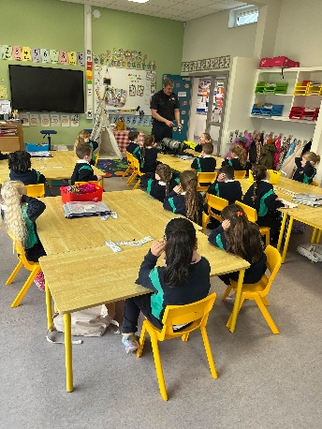
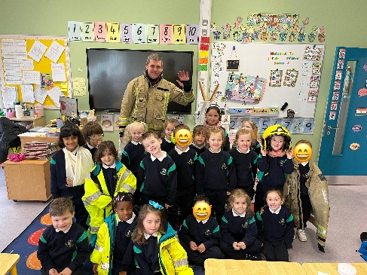
The boys and girls in Junior Infants were very excited to welcome firefighter/paramedic Alex from Dublin Fire Brigade. He showed us the equipment paramedics and fire fighters use, taught us how to call 999 and how to test our smoke alarm.
We learned all about the fire brigade and had lots of fun.
Huge thanks to Alex for taking the time to come in to visit us.

Parents Association
Many thanks to our PA for organising the Christmas card Initiative, which was a great success. It was lovely to see the children bring home their own designs and cards for their families. Our PA are organising a clothing collection on Tuesday 27th and Wednesday 28th of January. Our next PA meeting will take place on Tuesday the 20thof January in the school. All are welcome to attend.

PA Clothing Collection
We are having a fundraising clothing collection on Tuesday 27th and Wednesday 28th January.
We will accept items in any type of bag.
We Collect: Clothing, paired shoes, handbags, hats, scarves, ties, belts and soft toys. *Clean, folded bedding and curtains (*in a separate bag).
We cannot Collect: duvets and blankets, pillows and cushions, end-of-life clothing, mobile phones and tablets.


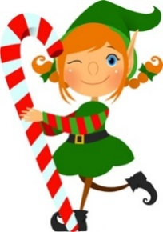
Junior Infants
This term has been very busy and exciting for our Junior Infants, from Halloween all the way to Christmas. We learned about “People Who Help Us,” especially the doctor and the fireman. The children enjoyed talking about how these helpers keep us safe and healthy, and they loved doing activities about their jobs. A big highlight was when Firefighter Alex came to visit our class. He showed us some of his equipment and spoke to the children about fire safety in a fun and simple way.
Science Week was another exciting part of our term. The children became little scientists as they took part in easy, hands-on experiments in the classroom. They made predictions, watched what happened, and talked about what they saw. We also visited the Holy Family science labs, where the older girls showed the children some wonderful experiments. The Junior Infants were amazed and enjoyed seeing science in action.
We spent some time outdoors planting bulbs at the front of the school. The children learned how to plant them carefully and talked about what plants need to grow. They are now looking forward to seeing the colourful spring flowers that will grow from their hard work.
As Christmas got closer, the children had great fun getting ready for the Junior Infant Jingle. They practised their songs and dances with lots of excitement and were very proud of their efforts. They also enjoyed doing plenty of Christmas art, using paint, glitter, and lots of creativity. It has been a joyful and very enjoyable term for our Junior Infants!

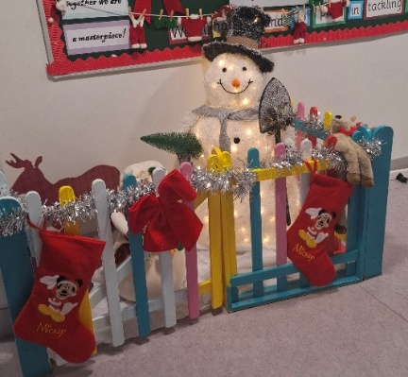

Senior Infants
Senior Infants have had a wonderful and fun filled few weeks since Halloween. We planted some bulbs out the front of our school and are really looking forward to seeing our flowers bloom in springtime. During Science week, our Senior Infant Scientists had great fun conducting various experiments and learning about famous inventors and the world around us.
The children have also been very busy doing lots of winter and Christmas art. This term we learned all about the Post Office, we even wrote and posted our own letters to our friends and families.
To finish off a busy term, we had great fun preparing for our Christmas Sing Along. The children learned a selection of Christmas songs and were delighted to share their festive performance with their families. Well done boys and girls!
Wishing you and your families a very merry Christmas and happy new year! Nollaig Shona Daoibh go leir.


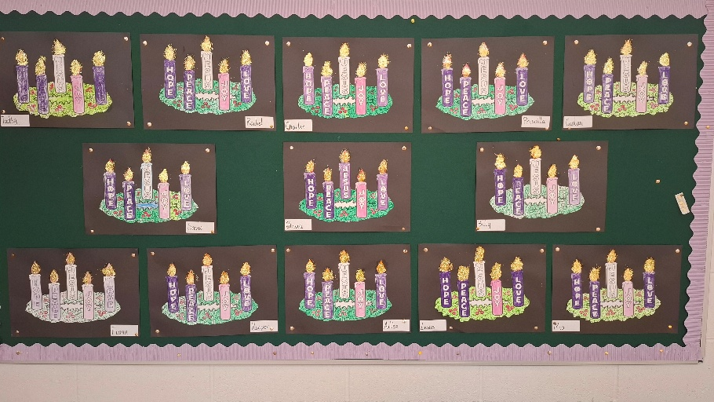

First Class
First Class have had a very busy few weeks, as First Class always do! We recently began our Picker Pals initiative, helping to clean up our local community with the assistance of our grown-ups in the evenings. We had an amazing Maths Week, with visits from 6th Class students, guiding us with Maths games and undertaking loads of news Maths activities for the week. We also had a great time during Science Week, with a visit from Junior Einsteins, carrying out a host of experiments! Our First Class Choir have been run off their feet, performing in the convent, for Deacon Jim, in the WhiteWater and for the school! They are ready for Broadway! We are also very excited for our First Class Carol Service in the church on the 17th.
On the 11th, our Green School Committee visited St. Conleth and Marys' for an information session on how to dispose of our waste properly, tying in with our new push to bring our waste home from school. And finally, we had a ball in the Riverbank Theatre at the Whistle Blast’s Christmas Show! There is no let up in 1st Class!!!
The countdown to Christmas is well and truly on. We would like to wish everyone a very happy and safe Christmas. Nollaig Shona Daoibh go léir!!



Office Hours
Please note that the office is closed each day for lunch from 1.20- 1.50.

Social Media
As many of you are aware our Instagram account is : social@stconlethinfantschool.ie If you wish to follow us. You can also follow us on our school website : www.stconlethinfantschool.ie and twitter page :St.Conleth’sInfants@SCInfantSchool

School closes on Friday 19th December @ 11.45 for Junior Infants, @ 11.50pm for Senior Infants and 1st Classes. School re-opens on Monday 5th January 2026
Wishing you a happy and safe Christmas and every good wish for 2026
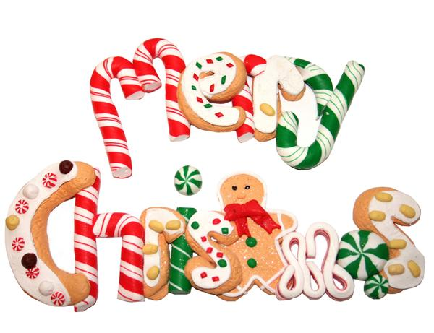

We would like to dedicate this Newsletter to Jamie- Lee Feane on his first anniversary.
