
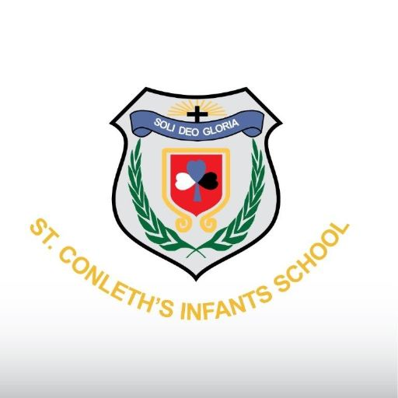St. Conleth’s Infant School
Annual Admission Notice
in respect of admissions to the 2027-2028 school year
Admission Policy and Application Form
A copy of the school’s Admission Policy and the Application Form for Admission for the 2027/28 school year is available as follows: –
To download at: www.stconlethinfantschool.ie
On request: By emailing office@stconlethinfantschool.ie or writing to St. Conleth’s Infant School, Newbridge., Co. Kildare W12WV88

Part 1 - Admissions to the 2027-28 school year

Application and Decision Dates for admission to 2027/28 school year
The following are the dates applicable for admission to Junior Infants

The school will commence accepting applications for admission on | 12/10/2026
The school shall cease accepting applications for admission on | 13/11/2026
The date by which applicants will be notified of the decision on their application is | 27/11/2026
The period within which applicants must confirm acceptance of an offer of admission is | 11/12/2026

Note: The school will consider and issue decisions on late applications in accordance with the school’s Admission Policy.

*Failure to accept an offer within the prescribed period above may result in the offer being withdrawn

Special Class Application and Decision Dates for admission to 2027-2028 school year
The following are the dates applicable for admission to the school’s Special Class which caters for children with school’s Special Class which caters for children with Autistic Spectrum Disorder

The school will commence accepting applications for admission to the special class on | 12/10/2026
The school shall cease accepting applications for admission to the special class on | 13/11/2026
The date by which applicants will be notified of the decision on their application for admission to the special class is | 27/11/2026
The period within which applicants must confirm acceptance of an offer of admission is | 11/12/2026

Number of Places being made Available in 2027-28 school year

The number of places being made available in junior infants | 104
The number of places being made available in the special class* catering for children with [insert category or categories of SEN catered for in the special class is | 1-Early Intervention class  1-Junior ASD class

Part 2 - Admissions to the 2026/27 school year.
Information regarding the admission process for the Intake Group for Junior Autism Special Class for the 2026-27 school year

In respect of the 2026-2027 school year, the total number of applications for admission received by the school was 25.
Breakdown of places allocated for the 2026-27 school year:
Number of places available: | 4 Junior Autism class
Number of applications received: | 25 Junior Autism class
Number of Offers made and accepted under each criteria: | Criterion One: Children already enrolled in the school(either mainstream or Early Intervention class) if they are transferring to a Special Class in the school with a diagnosis of autism)  4 places offered, 4 places accepted.  .
Total number of offers made | 4
Number of names placed on waiting list for the school year concerned. | 21

