Application for Admission to St. Conleth’s Infant Primary School
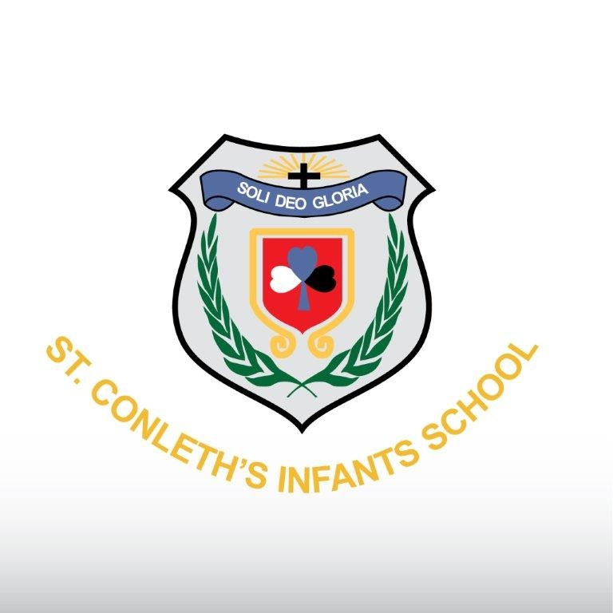
School Year 2027 – 2028
Please note that this form is for application purposes only. The information provided will be used to allocate places in accordance with the School’s Admission Policy/Annual Admission Notice (www.stconlethsinfantschool.ie). Please complete all sections of the form.

Class
Please tick one of the below only.

Junior Infants
Senior Infants
First Class
SEN – ASD ( Autism Class) Early Intervention
SEN – ASD ( Autism Class) Junior Infants – First Class
Please do not include assessments or reports with this application. Relevant reports including diagnoses will be requested where applicable and must be in place during the application period.
General Information on Child
First Name: | Surname:
PPS Number: | DOB: | Gender:
Home Address:

Eircode:
/

Siblings in the school: Yes No (Please tick)

Siblings previously enrolled: Yes No (Please tick)

Name(s) of sibling(s): Sibling’s class:

General Information on Parent(s)/Guardian(s)
Parent/Guardian | Parent/Guardian
Name: | Name:
Address (if different from child’s): | Address (if different from child’s):
Mobile No: | Mobile No:
Email address | Email address

Declaration:

I/We being the Parent(s)/Guardian(s) of the applicant do hereby confirm that the above information is true and accurate and I/we consent to its use as described.

Parent/Guardian’s Signature: | Parent/Guardian’s Signature:
Date: | Date:
Please return the fully completed form to
St Conleth’s Infant Primary School, Naas rd., Newbridge , Co Kildare, W12WV88.
Please note that applications will not be accepted via email.
Office Use only:
*Date Application Received | D | D | M | M | Y | Y
Data Privacy Statement
The information provided on this form will be used by St Conleth’s Infant Primary School to apply the selection criteria for enrolment in Junior Infants, and to allocate school places in accordance with the School’s Admission Policy and the School’s Annual Admission Notice.
Where a pupil is admitted to the school, the information will be retained on the pupil’s file.
On acceptance of an offer of admission, this information will be entered in the School Administration System Databiz and will be uploaded to the Primary Online Database. The Primary Online Database (POD) is a nationwide individualised database of primary school pupils, hosted by the Department of Education and Skills.
In the event of oversubscription, a waiting list of students whose applications for admission to St Conleth’s Infant Primary School were unsuccessful due to the school being oversubscribed will be compiled, and will remain valid for the school year in which admission is being sought.
Where a child’s name is placed on a waiting list, and the child is not admitted to the school, the information provided on this form will be retained for the duration of the school year and will be securely destroyed thereafter.
Section 66(6) of the Education (Admission to Schools) Act 2018 allows for the sharing of certain information between schools in order to facilitate the efficient admission of students. The information which may be provided to a patron or another Board of Management for this purpose may include all or any of the following:
(i) the date on which an application for admission was received by the school;
(ii) the date on which an offer of admission was made by the school;
(iii) the date on which an offer of admission was accepted by an applicant;
(iv) a student’s personal details including his or her name, address, date of birth and personal public service number (within the meaning of section 262 of the Social Welfare Consolidation Act 2005).

